**1: Setting Up JUnit**

**pom.xml**

<?xml version="1.0" encoding="UTF-8"?>  
<project xmlns="http://maven.apache.org/POM/4.0.0"  
 xmlns:xsi="http://www.w3.org/2001/XMLSchema-instance"  
 xsi:schemaLocation="http://maven.apache.org/POM/4.0.0 http://maven.apache.org/xsd/maven-4.0.0.xsd">  
 <modelVersion>4.0.0</modelVersion>  
  
 <groupId>org.example</groupId>  
 <artifactId>JUnit</artifactId>  
 <version>1.0-SNAPSHOT</version>  
  
 <properties>  
 <maven.compiler.source>17</maven.compiler.source>  
 <maven.compiler.target>17</maven.compiler.target>  
 <project.build.sourceEncoding>UTF-8</project.build.sourceEncoding>  
 </properties>  
 <dependencies>  
 <dependency>  
 <groupId>junit</groupId>  
 <artifactId>junit</artifactId>  
 <version>4.13.2</version>  
 <scope>test</scope>  
 </dependency>  
 <dependency>  
 <groupId>junit</groupId>  
 <artifactId>junit</artifactId>  
 <version>RELEASE</version>  
 <scope>test</scope>  
 </dependency>  
 </dependencies>  
  
</project>

**Calculator.java**

package org.example;  
  
public class Calculator {  
 public int add(int a, int b) {  
 return a + b;  
 }  
}

**CalculatorTest.java**

package org.example;  
  
import org.junit.Test;  
import static org.junit.Assert.*;  
  
public class CalculatorTest {  
  
 @Test  
 public void testAdd() {  
 Calculator calc = new Calculator();  
 int result = calc.add(2, 3);  
 System.*out*.println("Result = " + result);   
 *assertEquals*(5, result);  
 }  
  
}

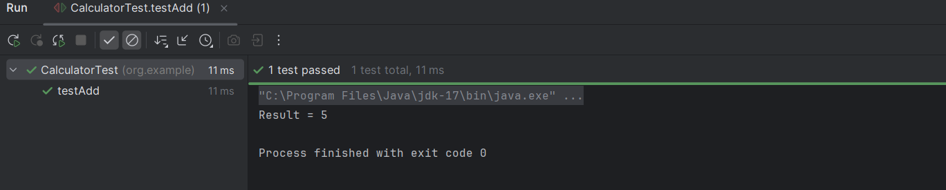

**3: Assertions in JUnit**

**AssertionsTest.java**

package com.example;  
  
import org.junit.Test;  
  
import static org.junit.Assert.*;  
  
public class AssertionsTest {  
  
 @Test  
 public void testAssertions() {  
 System.*out*.println("Running testAssertions...");  
 *assertEquals*(5, 2 + 3);  
 System.*out*.println("assertEquals passed");  
 *assertTrue*(5 > 3);  
 System.*out*.println("assertTrue passed");  
 *assertFalse*(5 < 3);  
 System.*out*.println("assertFalse passed");  
 *assertNull*(null);  
 System.*out*.println("assertNull passed");  
 *assertNotNull*(new Object());  
 System.*out*.println("assertNotNull passed");  
  
 System.*out*.println("All assertions passed!");  
 }  
}

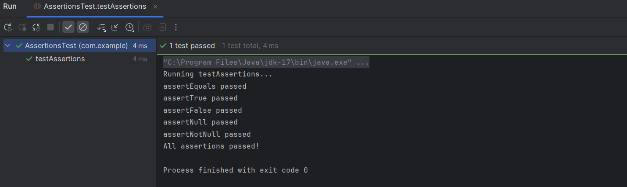

**4: Arrange-Act-Assert (AAA) Pattern, Test Fixtures, Setup and Teardown Methods in JUnit**

**Calculator.java**

package com.example;  
  
public class Calculator {  
 public int add(int a, int b) {  
 return a + b;  
 }  
  
 public int multiply(int a, int b) {  
 return a * b;  
 }  
}

**CalculatorTest.java**

package com.example;  
  
import org.junit.After;  
import org.junit.Before;  
import org.junit.Test;  
  
import static org.junit.Assert.*;  
  
public class CalculatorTest {  
  
 private Calculator calculator;  
 @Before  
 public void setUp() {  
 System.*out*.println("Setting up Calculator instance...");  
 calculator = new Calculator();  
 }  
 @After  
 public void tearDown() {  
 System.*out*.println("Tearing down Calculator instance...");  
 calculator = null;  
 }  
 @Test  
 public void testAdd() {  
 int result = calculator.add(2, 3);  
 *assertEquals*(5, result);  
 }  
  
 @Test  
 public void testMultiply() {  
 int result = calculator.multiply(4, 5);  
 *assertEquals*(20, result);  
 }  
}

